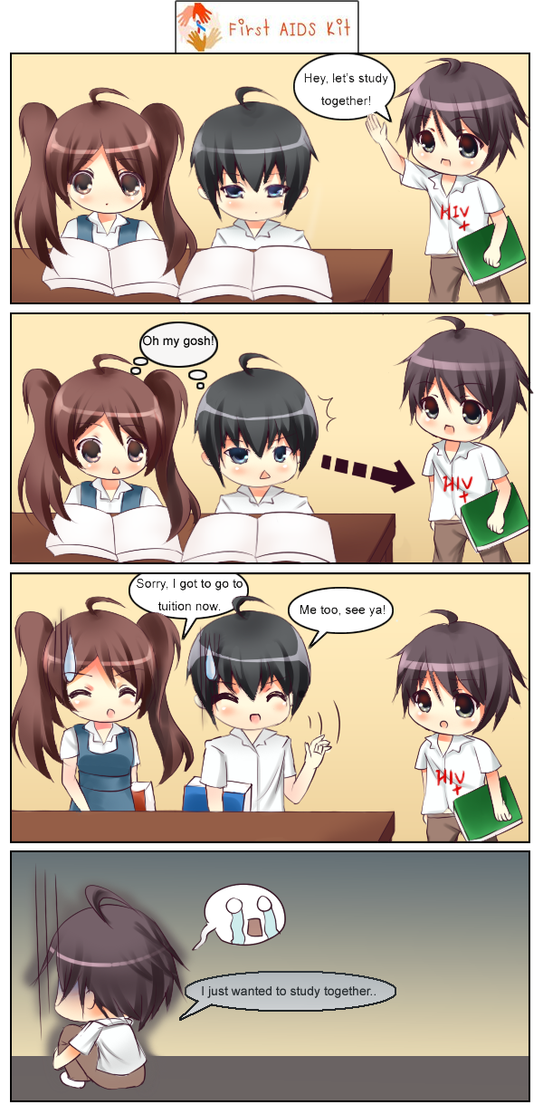
GET EDUCATED. STOP DISCRIMINATION.
PREVENT HIV. STOP DISCRIMINATION.
HIV: Human Immunodeficiency Virus
AIDS: Acquired Deficiency Syndrome
It’s easy to think that AIDS is something for other people to worry about-drug users, sex workers, gay people, people who sleep around. This is WRONG- all teens, whoever they are, wherever they live need to take the threat of HIV seriously. To be able to protect yourself, you need to know the facts, and know how to avoid becoming infected.
The most common ways that people become infected with HIV are:
- Having sexual intercourse with an infected partner.
- Injecting drugs using a needle or syringe that has been used by someone who is infected.
- As a baby of an infected mother, during pregnancy, labour or delivery, or through breastfeeding.
How can I tell if someone’s infected with HIV?
There is no way to tell just by looking at someone whether they are infected with HIV. Some one can be infected but have no symptoms and still look perfectly healthy. The only way to know if a a person is infected or not is if they have a blood test.
I Have HIV, what should I do?
If you have found out that you have HIV, you will need to tell the people who you have had sex with and anyone you have shared needles with so that they can decide if they want to have a test.
Is there a cure?
There is no cure for HIV. HIV is a virus, and no cure has been found for any type of virus. Recently, doctors have been able to control the virus once a person is infected, which means that a person with HIV can stay healthy for longer, but they have not managed to get rid of the virus in the body completely.
To learn more about HIV/AIDS, please visit the UNICEF Voices of Youth or Malaysian Aids Council website at www.unicef.org/voy or www.mac.org.my


